BANKURA UNIVERSITY

**BANKURA SAMMILANI COLLEGE**

**A study on anthropometric parameters (height and weight)**

**of college students**

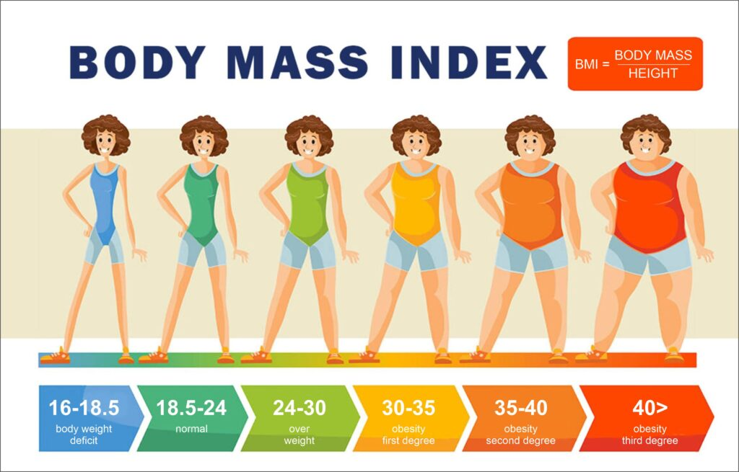

***Submitted by***

**Name: ABHIJIT MANDAL**

**UID number:1021904380**

**Subject: Zoology (Honours)**

**Semester: VI**

***Supervised by***

**DR. SURAJIT MAJUMDER**

**Associate Professor**

**Department of Zoology**

**BANKURA SAMILANI COLLEGE**

**ACKNOWLEDGEMENT**

As a participant of this project, which would be a crucial representation of facts about nutritional status of our near-by social groups, I here-by express my gratitude towards the persons, without whom, this would not have been possible to deal with.

* First of all, I am grateful towards the ‘Undergraduate Board of Studies’ & ‘Bankura University, West Bengal’, for including this project-work in our syllabus.
* The respected Principal of our college, Dr. Samir Kumar Mukherjee & our ‘Head of the Department’, Dr. Tapas Kumar Dutta, for providing us with the facilities to work on this project.
* I am grateful towards Dr. Malay Kumar Patsa, the ‘Head of the Nutrition Department’ of our college, for guiding us thoroughly and teaching us the technicalities of the instruments in use, ideas about graphical representations and providing us with the standard data for this project.
* Also, I am specially obliged to our respected Professor of our own, ‘Zoology Department’, Dr. Surajit Majumder, for his unparalleled guidance and mentorship, while working on the wholesome of this project.
* To the respected Professors of our department - Mr.Rajendra Prasad Mondal, Dr.Ananya Nayak & Dr.Muktipada Bag.
* The Lab-assistants of our ‘Zoology Department’ - Sri Biswarup Chattopadhyay & Sri Srikanta Karmakar, for their succoring towards us, when it came to deal with the measuring processes with the help of instruments.

Last but not the least, I feel pleased to give my sincerest thanks to the candidates who volunteered in this project & my fellow classmates for their co-operations through process.

Date: 28th March, 2022 _______________

@Bankura Sammilani College

P.O. – Bankura

Dist. – Bankura

Pin. – 722101

**CONTENT**

**1. INTRODUCTION**

**1.1 Nutritional status and the state of nutritional imbalance**

Nutrition is the basic pillar of human health. At every stages of life, proper nutrition is prerequisite for survival, growth and development, work efficiency and productivity, health and well-being. It is the basis of human development as well as the development of the nation (WHO, 2000).

Nutritional status is the state of body that is determined by the intake and usage of nutrients. It is considered as an important and positive indicator of health as well as growth and development. The nutritional status is usually a consequence of multiple factors interlinking with one another. But consumption of adequate amount of food both in amount and quality is the main determinant of the nutritional status of a person, as well as the populace (Shrivastava *et al*., 2014).

Nutritional status mirrors the degree to which the physiological necessities of nutrients of an individual have been covered at a specific life stage. When the nutrients to prop up day-to-day bodily demands and metabolic needs are consumed in a balanced way the individual presents an optimal nutritional status (Picó *et al*., 2019).

The state of imbalance in nutrition is known as malnutrition (Upadhyay *et al*., 2017). Malnutrition is a pathological condition resulted from a partial or complete insufficiency or surplus of at least one essential nutrients (Park, 2015).It may be of two forms – undernutrition and overnutrition. Undernutrition is the state resulted primarily from insufficient consumption of energy and nutrients to satisfy the needs of an individual for maintaining good health (Maleta, 2006). On the other hand, overnutrition is a state of over consumption of calories and nutrients beyond levels need for growth and development as well as metabolic activity (Shetty, 2003). Undernutrition may represent in two forms – protein energy malnutrition (PEM) and micronutrient deficiencies.

PEM is as a pathological state resulted from coincident deficiencies of protein and calorie and often associated with infection (Banstola, 2012). Micronutrient deficiencies are very widespread and probably one of the main nutritional problems in the world (Allen, 2013). It is considered as silent epidemics and can affect people of all genders and ages including certain risk groups (Tulchinsky, 2010).

**1.2 Anthropometric measurements**

Anthropometric measurements mean body measurements and provide information on body muscles mass and fat reserves. The pattern of growth and physical state of the body are profoundly influenced by diet and nutrition. Hence, anthropometric measurements are useful criteria for assessing nutritional status.

Anthropometric measurement is useful criteria for assessing nutritional status as it reflects morphological variations resulted from dietary intake of energy and nutrients. It helps to detect subclinical forms of undernutrition and can identify ‘at-risk’ groups. These measurements can easily be taken in all circumstances, and therefore, these are commonly used in nutritional survey.

A large number of anthropometric measurements are used in assessing nutritional status and they have varying degree of importance at different age period. But the most important anthropometric measurements are weight and height.

**Weight:**

* Weight most widely used fundamental measurement for assessing growth and nutritional status.
* It is sensitive, simplest and reproducible measurement.
* It indicates the body mass and as well body composition.

**Height:**

* Height is a very reliable parameter that reflects the total increase in size of individual upto the moment it is determined.
* Height is considered as an index of chronic malnutrition, as it is affected only by long duration nutritional deprivation.

**2. OBJECTIVE OF THE STUDY**

This study was conducted with following objectives –

1. To measure the two important anthropometric parameters – weight and height of the college students.
2. To assess the nutritional status of the college students from their body mass index.
3. To compare the anthropometric parameters of male and female college students.

**3. METHODOLOGY**

**3.1 Study design and the sample**

To conduct this study a cross-sectional study design was used. The participants of this study were the college student of both sexes. Fifty college students ( 25 male and 25 female) were selected from Bankura Sammilani College by random sampling.

**3.2 Anthropometric measurement**

Two anthropometric parameters, weight and height were used in this study and measurement of these parameters was taken by using appropriate techniques as suggested by World Health Organization (WHO, 1995). Date of birth of the students were recorded from ‘Admit Card’ of Madhyamik Examination.

1. **Measurement of weight:**

Weight was measured by using weighing machine. To measure weight, the subject was asked to stand straight on the platform of the weighing machine with bare foot and minimal clothing. Reading was taken from the scale of the instrument. Measurement was taken thrice and their mean was recorded as final measurement. Before each measurement the machine was checked for zero adjustment and corrected as and when required.

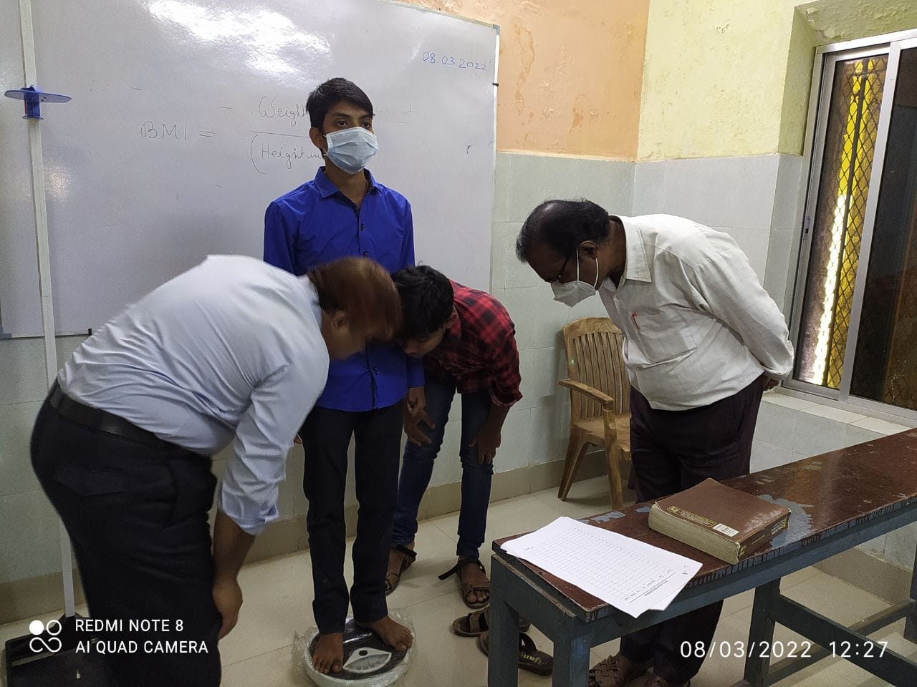

1. **Measurement of height:**

Height was measured by using anthropometer. To measure height, the subject was advised to stand on platform, without shoes, with feet parallel and heels, buttock, head and shoulders touching the wall and arm hanging at the sides in a relaxed manner. Reading was taken from the scale of the instrument. Measurement was taken thrice and their mean was recorded as final measurement.

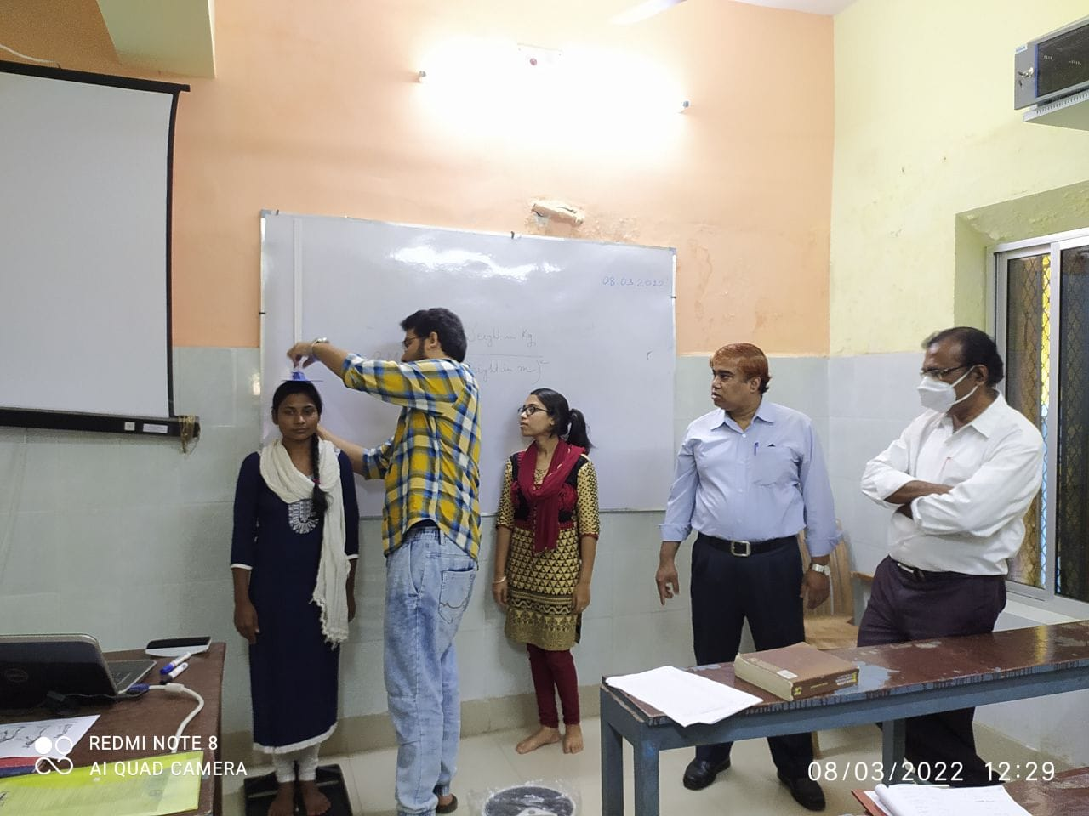

**3.3 Determination of nutritional status**

As body mass index (BMI) is the most important indicator for assessing nutritional status of adults, nutritional status of the college students were determined by computing BMI. From weight and height, the body mass index (BMI) was computed by using following formula –

Weight in kg

BMI = --------------------------

(Height in meter)2

To determine the nutritional status of the college student the cut-off value of WHO was used which is as follows –

|  |  |
| --- | --- |
| **BMI** | **Nutritional status** |
| Below 18.50 | Underweight |
| 18.50 - < 25.00 | Normal |
| 25.00 - < 30.00 | Over weight (Pre obese) |
| 30.00 - < 35.00 | Obesity grade I |
| 35.00 - < 40.00 | Obesity grade II |
| 40.00 and above | Obesity grade III |

**4. RESULTS**

**4.1 Presentation of data**

**Table: Anthropometric parameters of male college students**

|  |  |  |  |  |  |  |
| --- | --- | --- | --- | --- | --- | --- |
| **Case no.** | **Date of birth** | **Age** | **Weight(kg)** | **Height(m)** | **BMI** | **Nutritional status** |
| 1 | 03/11/2001 | 20 | 62 | 1.69 | 21.7 | Normal |
| 2 | 22/0/2000 | 22 | 68.5 | 1.72 | 23.2 | Normal |
| 3 | 01/03/2002 | 20 | 65 | 1.65 | 23.9 | Normal |
| 4 | 18/03/2002 | 20 | 45 | 1.66 | 16.3 | Under Weight |
| 5 | 08/01/2002 | 20 | 57 | 1.58 | 22.8 | Normal |
| 6 | 05/05/2000 | 22 | 47 | 1.54 | 19.8 | Normal |
| 7 | 21/07/2000 | 22 | 96.7 | 1.82 | 29.2 | Over Weight |
| 8 | 01/11/2000 | 22 | 62 | 1.67 | 22.2 | Normal |
| 9 | 15/11/2002 | 20 | 51 | 1.58 | 20.4 | Normal |
| 10 | 23/01/2002 | 22 | 58.8 | 1.65 | 21.5 | Normal |
| 11 | 27/04/2002 | 20 | 67 | 1.80 | 20.47 | Normal |
| 12 | 24/02/2002 | 20 | 68 | 1.70 | 23.42 | Normal |
| 13 | 22/03/2002 | 20 | 53 | 1.67 | 19.00 | Normal |
| 14 | 03/09/2002 | 19 | 76 | 1.70 | 26.20 | Over Weight |
| 15 | 30/01/2002 | 20 | 70.5 | 1.70 | 24.39 | Normal |
| 16 | 22/04/2002 | 19 | 51 | 1.69 | 17.77 | Under Weight |
| 17 | 22/11/2001 | 20 | 71.5 | 1.67 | 25.39 | Over Weight |
| 18 | 26/04/2002 | 20 | 62 | 1.68 | 21.96 | Normal |
| 19 | 04/05/2002 | 20 | 60 | 1.75 | 19.59 | Normal |
| 20 | 12/12/2001 | 20 | 45 | 1.58 | 17.84 | Under Weight |
| 21 | 02/05/1998 | 23 | 53 | 1.61 | 20.29 | Normal |
| 22 | 03/11/2003 | 18 | 80 | 1.69 | 27.91 | Over Weight |
| 23 | 14/01/2003 | 19 | 68 | 1.65 | 24.88 | Normal |
| 24 | 07/12/2003 | 18 | 67 | 1.63 | 25.03 | Over Weight |
| 25 | 14/03/2004 | 18 | 84 | 1.68 | 29.51 | Over Weight |
|  | **Mean** | | 63.56 | 1.67 | 22.58 | Normal- |

**Table: Anthropometric parameters of female college students**

|  |  |  |  |  |  |  |  |  |  |  |
| --- | --- | --- | --- | --- | --- | --- | --- | --- | --- | --- |
| **Case no.** | **Date of birth** | | **Age** | | **Weight(kg)** | | **Height (m)** | | **BMI** | **Nutritional status** |
| 1 | 09/03/2000 | | 22 | | 55 | | 1.61 | | 21.21 | Normal |
| 2 | 17/07/2001 | | 21 | | 54 | | 1.62 | | 20.34 | Normal |
| 3 | 22/10/2001 | | 20 | | 42 | | 1.50 | | 18.61 | Normal |
| 4 | 15/05/2002 | | 20 | | 46 | | 1.49 | | 20.55 | Normal |
| 5 | 20/07/2001 | | 20 | | 61 | | 1.52 | | 26.19 | Over Weight |
| 6 | 15/04/2000 | | 22 | | 75 | | 1.60 | | 29.11 | Over Weight |
| 7 | 27/03/2002 | | 20 | | 53 | | 1.52 | | 22.94 | Normal |
| 8 | 17/08/2001 | | 21 | | 59 | | 1.55 | | 24.31 | Normal |
| 9 | 11/08/2002 | | 20 | | 48 | | 1.51 | | 20.83 | Normal |
| 10 | 11/03/2001 | | 21 | | 43 | | 1.59 | | 16.94 | Under Weight |
| 11 | 11/06/2002 | | 20 | | 52.5 | | 1.66 | | 19.06 | Normal |
| 12 | 08/04/2001 | | 21 | | 61 | | 1.66 | | 21.92 | Normal |
| 13 | 21/05/2001 | | 21 | | 56 | | 1.54 | | 23.50 | Normal |
| 14 | 08/09/2001 | | 20 | | 44 | | 1.49 | | 19.8 | Normal |
| 15 | 16/06/2002 | | 20 | | 49 | | 1.46 | | 23 | Normal |
| 16 | 27/05/2002 | | 20 | | 49 | | 1.55 | | 20.3 | Normal |
| 17 | 11/03/2001 | | 21 | | 51 | | 1.52 | | 21.9 | Normal |
| 18 | 15/05/2002 | | 20 | | 46 | | 1.58 | | 18.4 | Under Weight |
| 19 | 19/03/2000 | | 22 | | 53 | | 1.57 | | 21.4 | Normal |
| 20 | 25/11/2001 | | 20 | | 39 | | 1..48 | | 17.7 | Under Weight |
| 21 | 27/01/2002 | | 21 | | 43.5 | | 1.46 | | 20.4 | Normal |
| 22 | 16/12/2001 | | 20 | | 52 | | 1.55 | | 21.5 | Normal |
| 23 | 20/09/2001 | | 20 | | 45 | | 1.53 | | 19.1 | Normal |
| 24 | 14/11/2001 | | 20 | | 48 | | 1.50 | | 21.2 | Normal |
| 25 | 05/08/2002 | | 20 | | 63 | | 1.58 | | 25.23 | Over Weight |
|  |  | Total | | 51.52 | | 1.54 | | 21.41 | | Normal |

**Table: Sex-wise comparison of mean weight, height and BMI**

|  |  |  |  |
| --- | --- | --- | --- |
| **Sex** |  | **Mean height** | **Mean BMI** |
| Male | 63.56 | 1.67 | 22.58 |
| Female | 51.52 | 1.54 | 21.41 |

**Table: Sex-wise comparison of nutritional status**

|  |  |  |  |  |
| --- | --- | --- | --- | --- |
| **Sex** | **Underweight** | **Normal** | **Overweight** | **Obesity grade I** |
| Male | 3 | 16 | 6 | 0 |
| Female | 3 | 19 | 3 | 0 |

**4.3 Graphical representation and interpretation of data**

**4.3.1. Graphical representation of Weights (kg) of college students :**

**4.3.1.a. Fig: Weights(kg) of male college students.**

**4.3.1.b Fig: Weights(kg) of female college students.**

**4.3.2. Graphical representation of Heights(m) of college students :**

**4.3.2.a. Fig: Height(m) of male college students.**

**4.3.2.b. Fig: Height(m) of female college students.**

**4.3.3.a. Fig: BMI (kg/m2) of male college students.**

**4.3.3.b. Fig: BMI(kg/m2) of female college students.**

**4.3.4. Graphical representation of the comparison between BMI of male & female college students:**

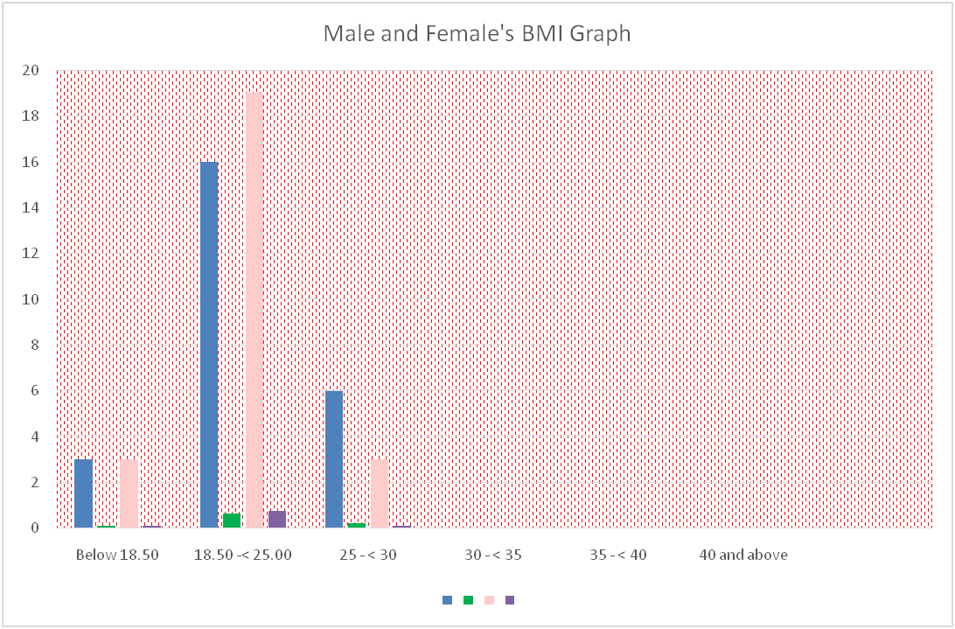

**4.3.4. Fig: Comparative analysis of BMI of Male & Female college students.**

**4.3.5. Graphical representation of the comparison between BMI of male & female college students:**

|  |  |  |  |  |
| --- | --- | --- | --- | --- |
| **4.3.5. Fig: Comparative analysis of Nutritional Status of Male and Female college students.** |  |  |  |  |

**4.CONCLUSION:**

Form the analysis of data it is found that 64% of male students and 76% of female student have normal Nutritional status. Remaining students are either underweight or over weight. So, it can be concluded that the nutritional status of the college student under study is not satisfactory.

**5.REFERENCES:**

* Allen LH. Interventions for micronutrient deficiency control in developing countries: past, present and future. J Nutr 2013; 133(11):3875S–3878S.
* Banstola A. Prevalence of energy malnutrition in children under five years and service delivery responses in Nepal. Int J Health Sci Res 2012; 2(7):79-90.
* Maleta K, Undernutrition. Malawi Medical Journal 2006; 18 (4):189-205.
* Park K. Park’s Textbook of Preventive and Social Medicine (23rd edition). Banarsidas Bhanot Publishers, Jabalpur 2015.
* Picó C, Serra F, Rodríguez AM, Keijer J, Palou A. Biomarkers of Nutrition and Health: New Tools for New Approaches. Nutrients 2019; 11(1092):1-30.
* Shetty P. Malnutrition and undernutrition. Medicine (Baltimore) 2003; 31(4):18-22.
* Shrivastava SRBL, Shrivastava PS, Ramasamy J. Assessment of Nutritional Status in the Community and Clinical Settings. J Med Sci 2014; 34(5):211-213.
* Tulchinsky T. Micronutrient deficiency conditions: Global health issues. Public Health Reviews 2010; 32(1):243-255.
* Upadhyay R, Tripathi KD. How Can We Assess the Nutritional Status of an Individual? J Nutr Food Sci 2017; 7(6):1-2.
* WHO, Technical Report Series, 854. World Health Organization, Geneva 1995.
* WHO. Nutrition for Health and Development: A global agenda for combating malnutrition World Health Organization, Geneva 2000.